**Configure VPN between Mumbai and Ohio Lab 3 of 4**

Go to Security Group “Mumbai_Linux_sec_Group”.

Click “Edit “ and then click “Add Rule”.

Allow all traffic from 192.168.0.0/16 subnet.

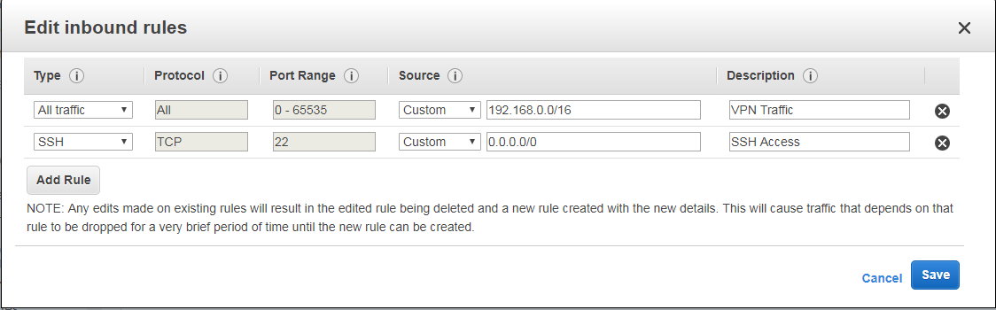

Then click save.

Goto Mumbai region to get public ip address of VPN Server Interface (13.127.161.231)

Launch putty key generator in your local machine,

In File 🡪 Load private key

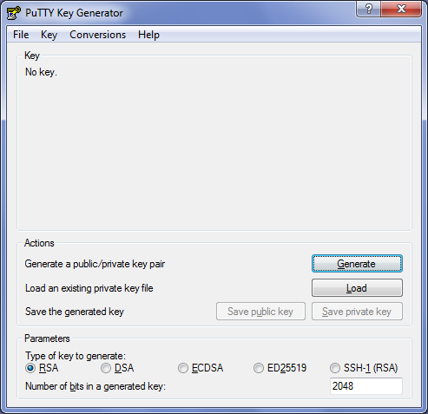

Locate the *.pem file and click “open”.



Click ”Ok:”.

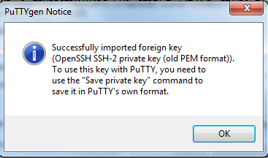

Click “save Private Key”.

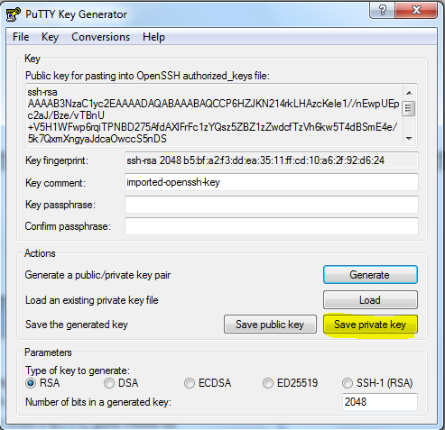

Click “Yes”.

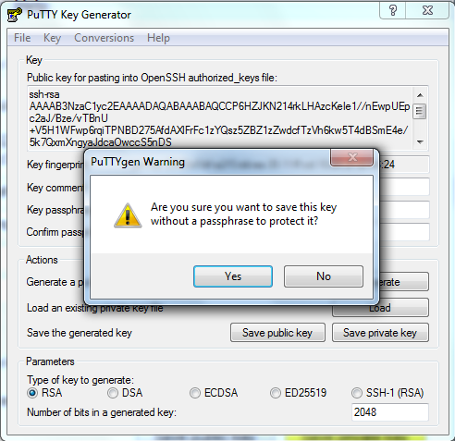

Save the private key in location.



Type the ip address in putty.

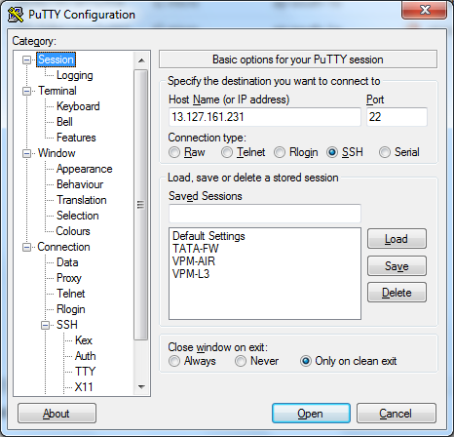

Click SSH and expand it click “Auth”.

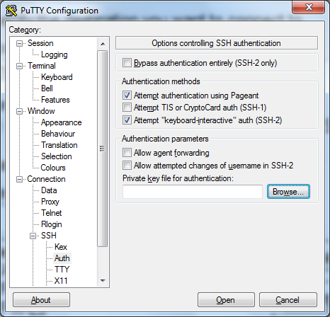

Click browse and locate the *.ppk file.

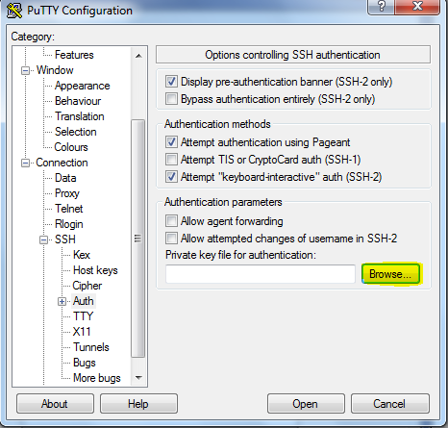

Locate the file and click “Open”.



Click “Yes”.

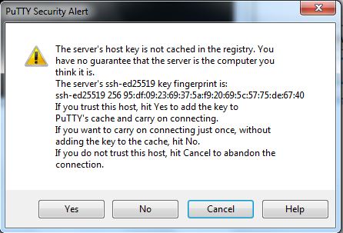

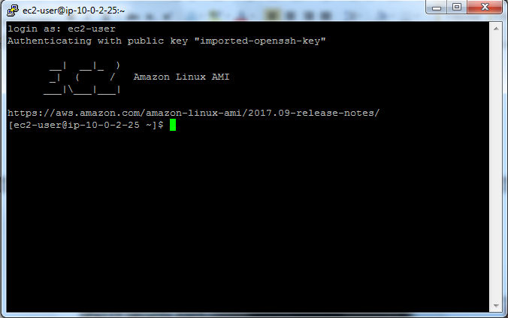

Type

sudo-i

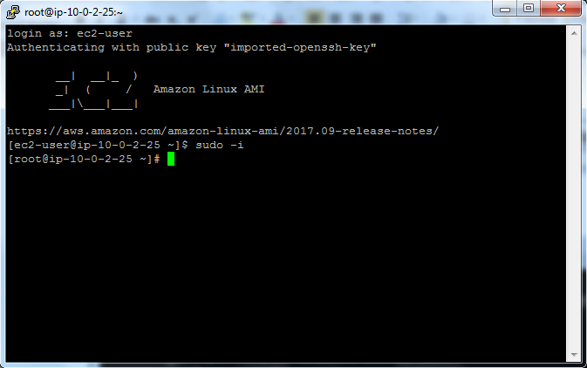

Type

Yum update -y

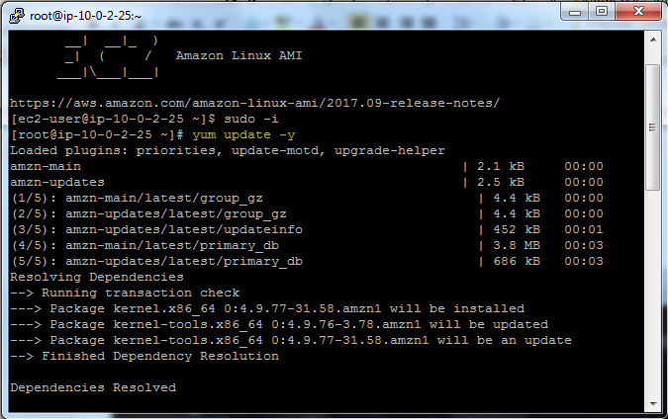

Type

Yum install openswan -y

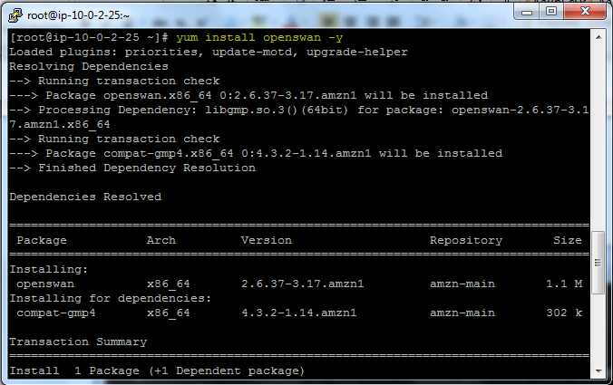

Cd /etc

Vi ipsec.conf

In ipsec.conf file we need to **remove # from** #include /etc/ipsec.d/*.conf line

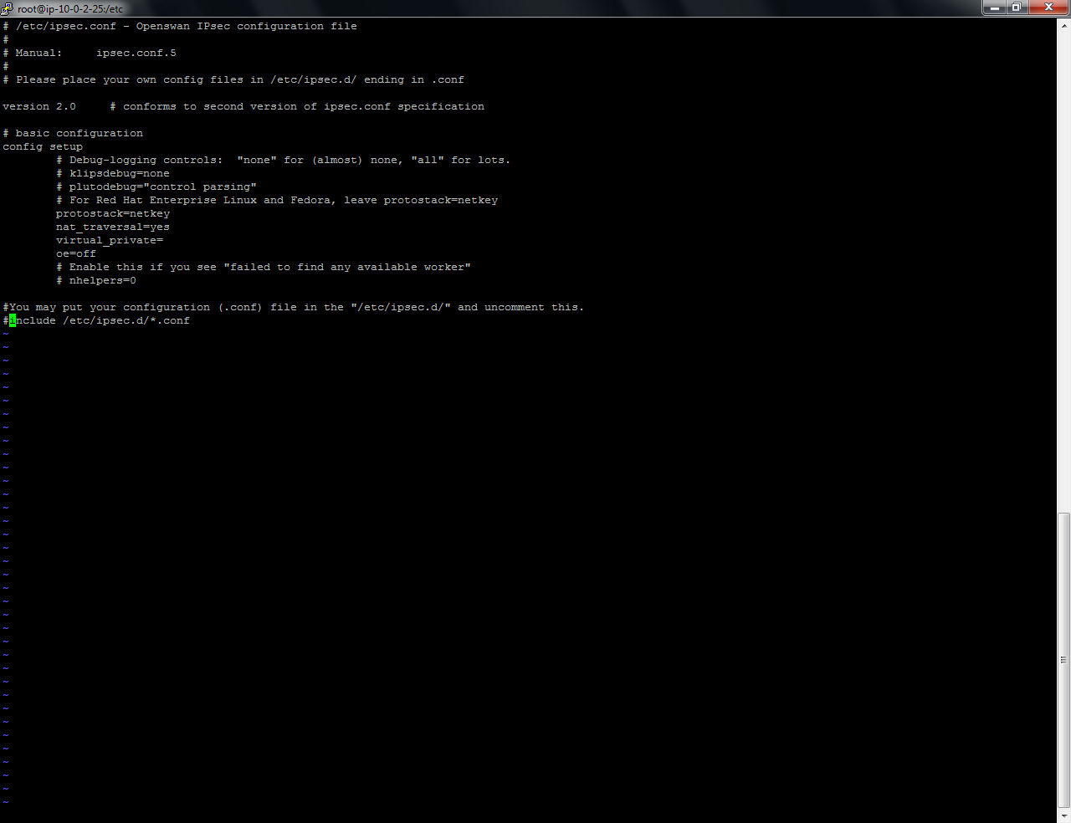

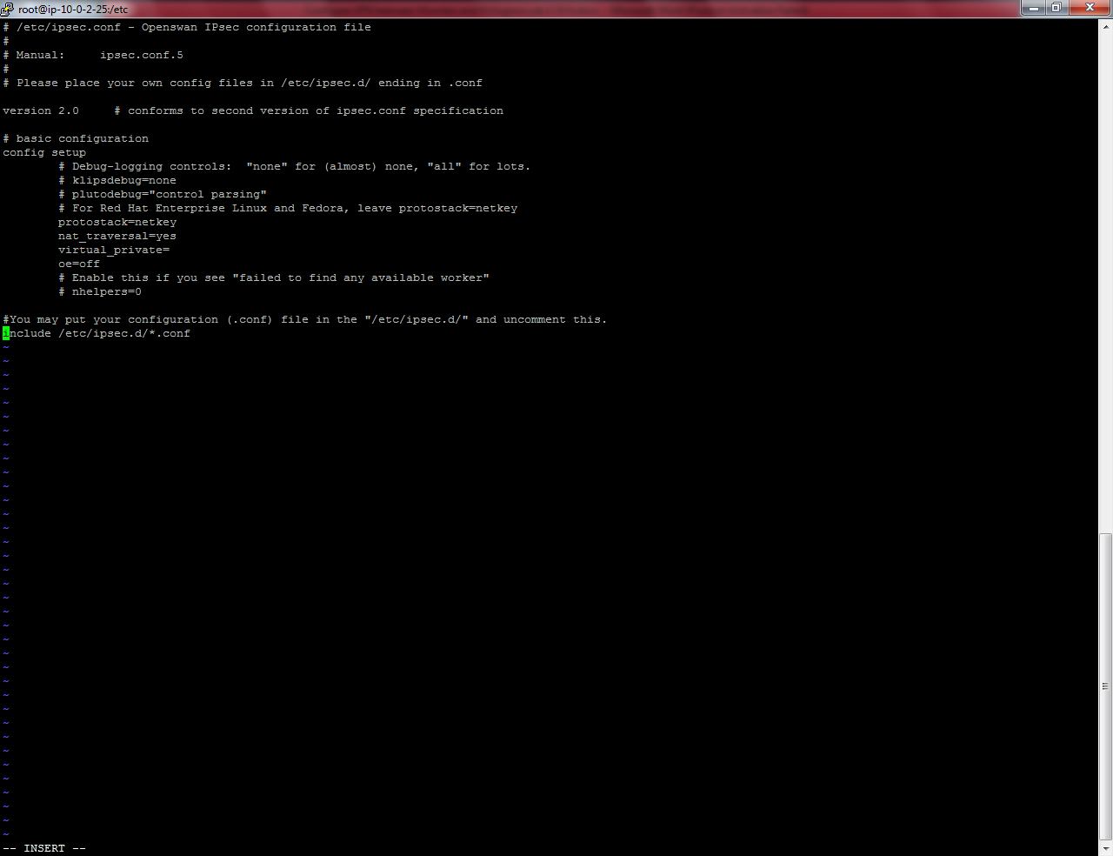

Press Escape key

Type :wq

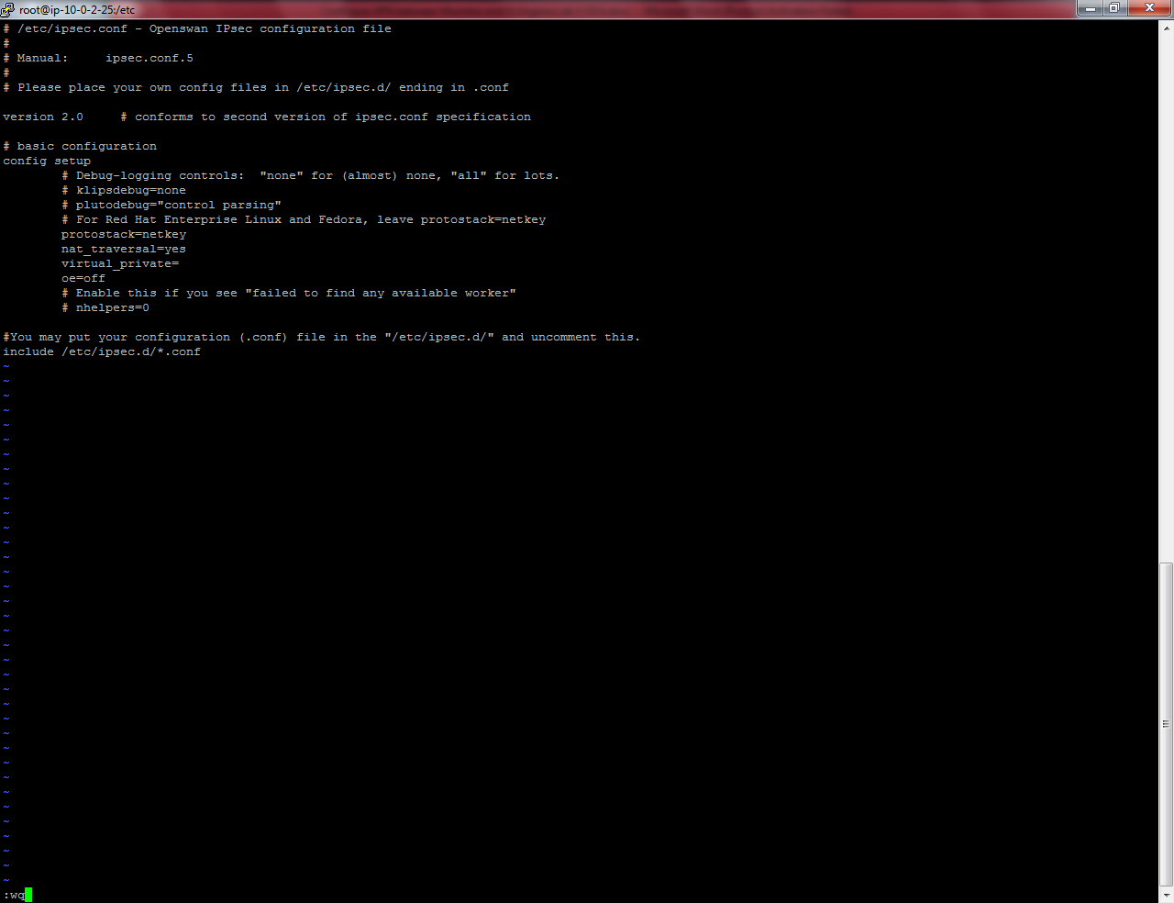

Type

Vi ipsec.d/mum-to-ohio.conf

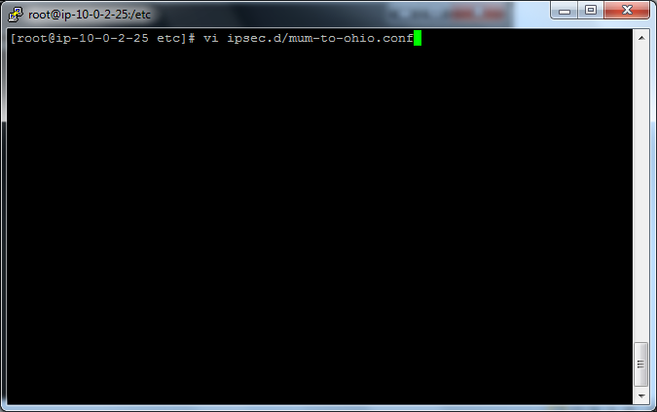

Type

Chkconfig ipsec on

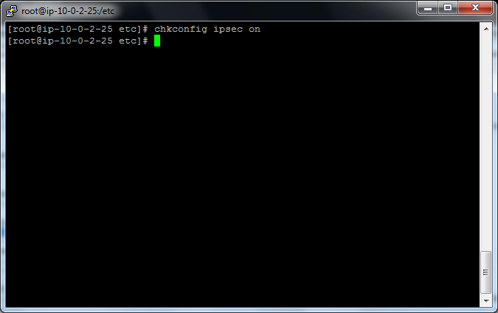

Copy the command to below editor.

conn mum-to-ohio

type=tunnel

authby=secret

left=defaultroute

leftid=13.127.161.231

leftnexthop=%defaultroute

leftsubnet=10.0.0.0/16

right=18.218.11.25

rightsubnet=192.168.0.0/16

pfs=yes

auto=start

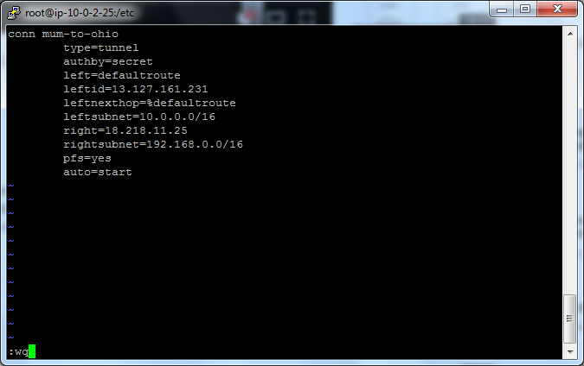

Press escape and type :wq

Type

Vi ipsec.d/mum-to-ohio.secrets

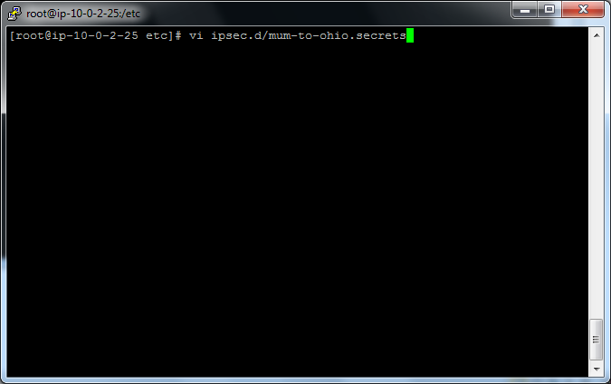

TYPE EIP1 (Mumbai EIP) and type EIP2 (Ohio EIP) then type : PSK “Preshared key of the tunnel”.

Our Tunnel Preshared key is “Sansbound”

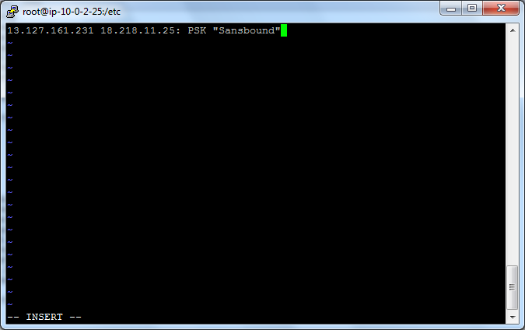

Press escape key

Type :wq

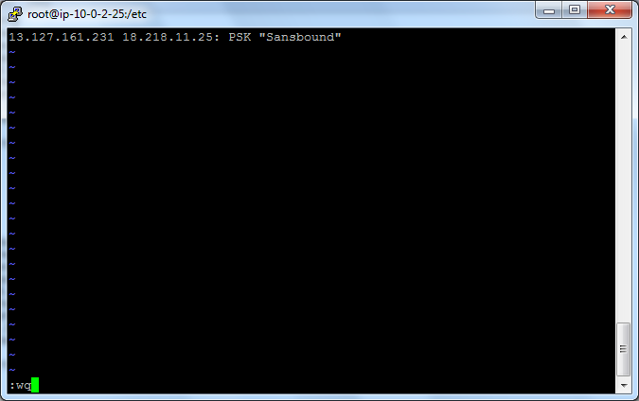

Service ipsec start

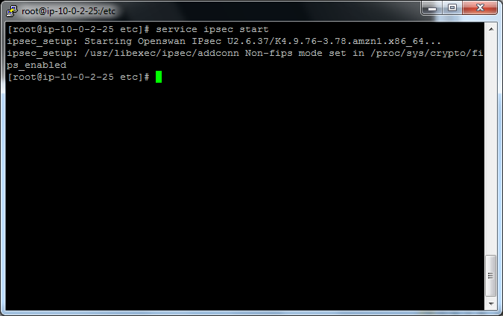

Type sysctl.conf

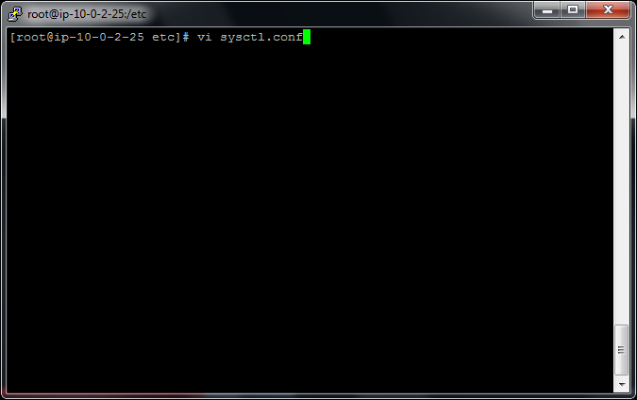

Press insert and then change the value as below.

Change

net.ipv4.ip_forward = 1

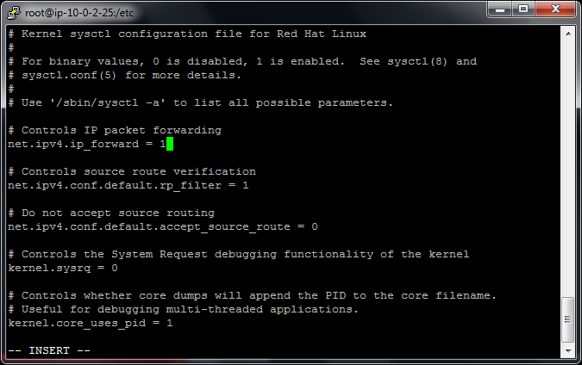

Press “Escape” key

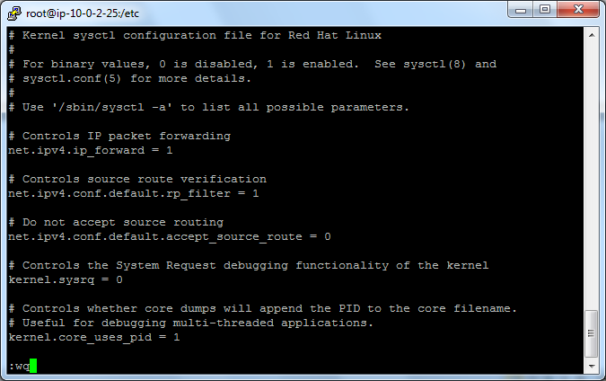

and then type

:wq

Go to Ec2 Dashboard

Click “Network interface” and then select “OpenSwan”

Click “Actions” 🡪 Click “Change source/destination check”

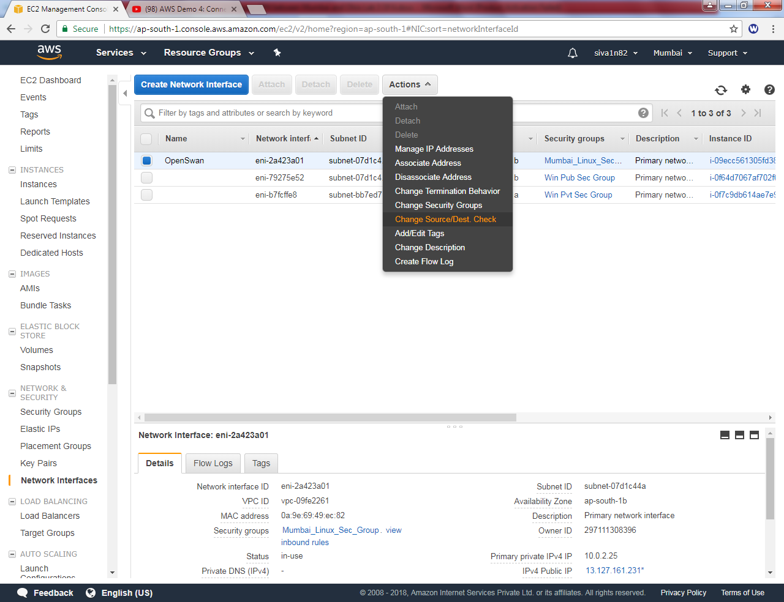

Set it as “Disabled”and click “save”.

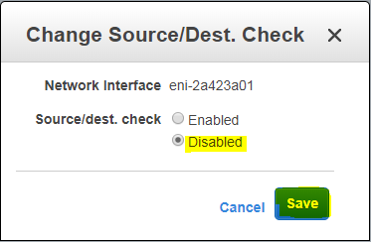

Type

Service network restart

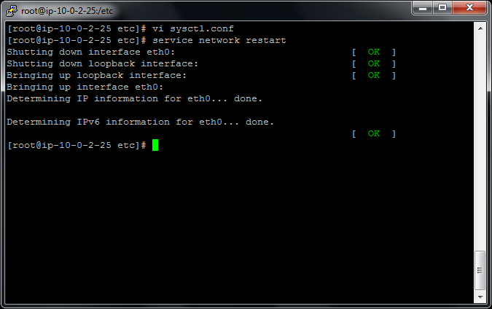

Type vi sysctl.conf

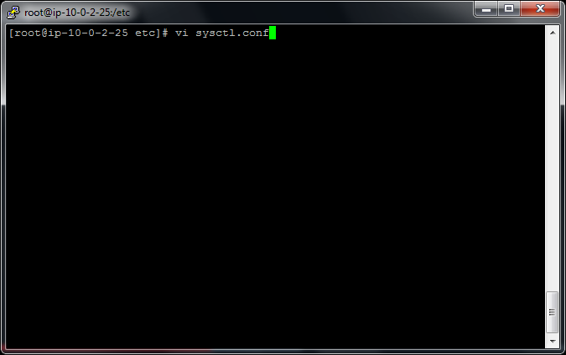

Press insert key

Type

net.ipv4.conf.all.accept_redirects = 0

net.ipv4.conf.all.send_redirects = 0

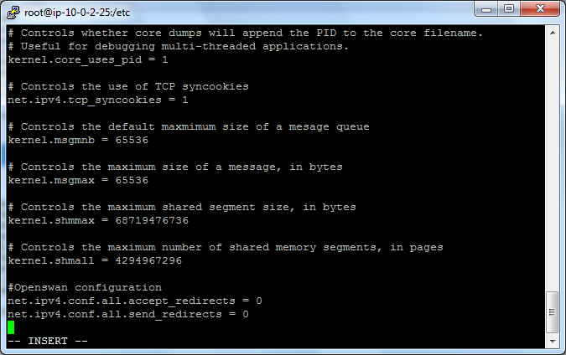

Press escape key and type

:wq

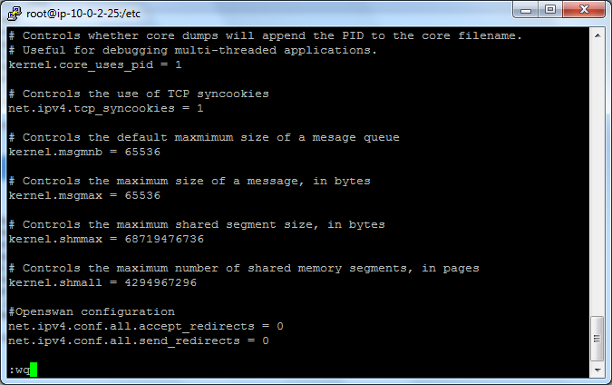

Type

Service network restart

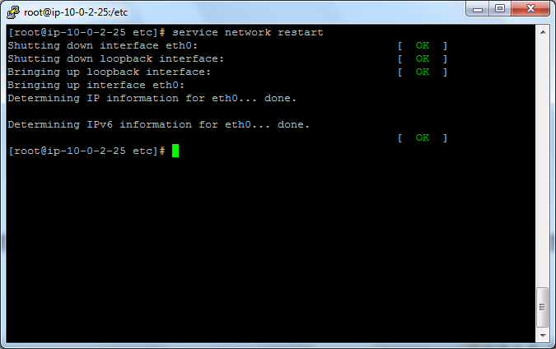

Go to VPC dashboard,

Click Route table, select sansbound public route table,

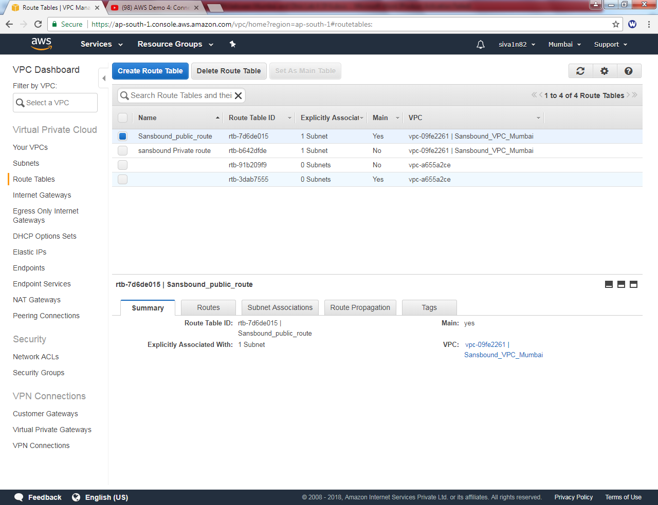

Click “Edit

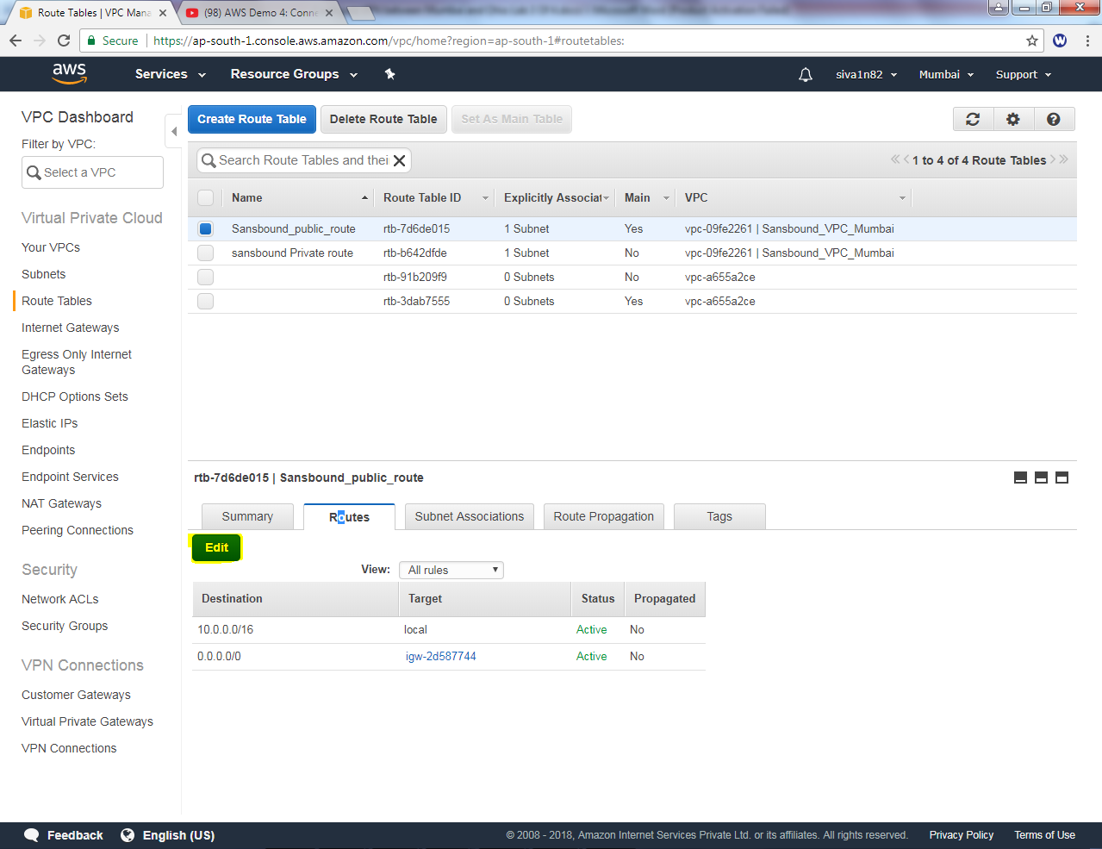”

Click “add another route” and then type 192.168.0.0/16 as destination and select “Linux VPN Server” as target.

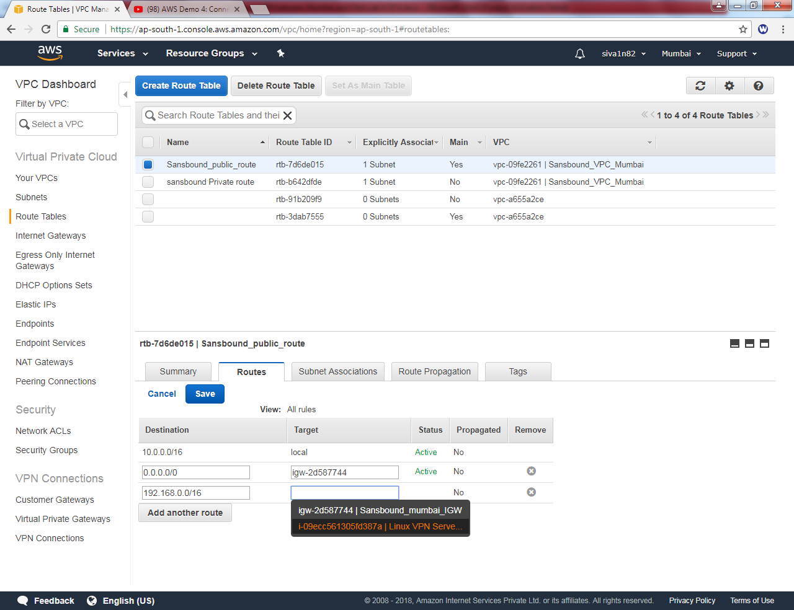

Click “save”.

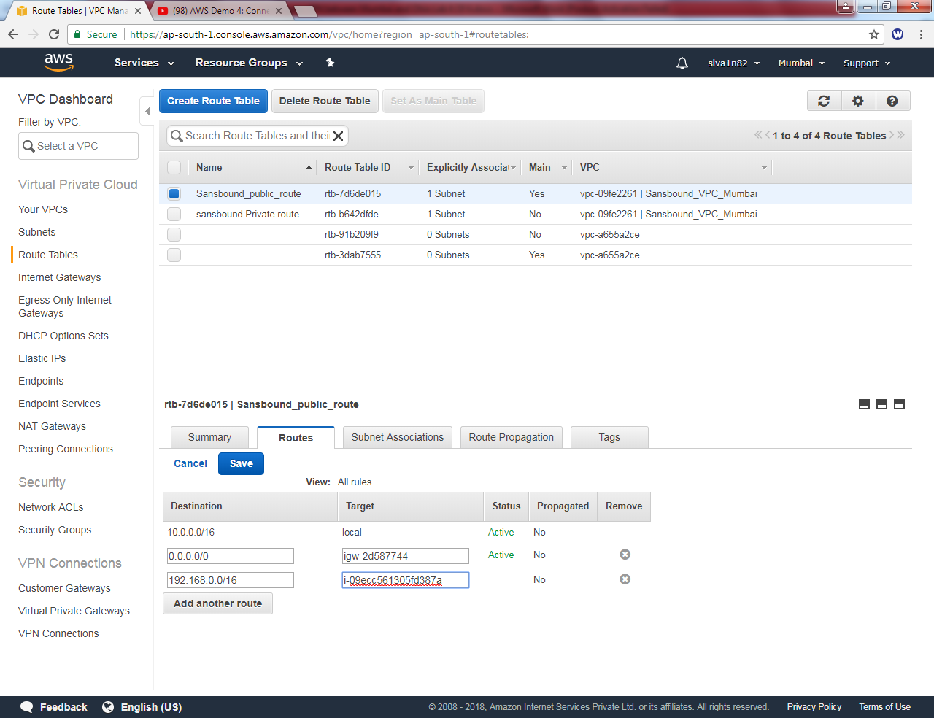

Detailed information of route table.

